SERVER UML DIAGRAM

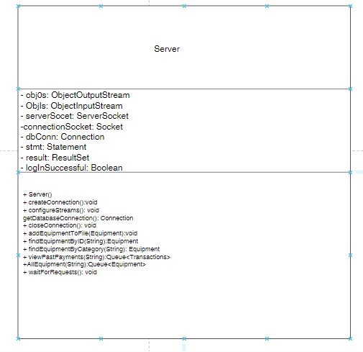

CLIENT UML DIAGRAM

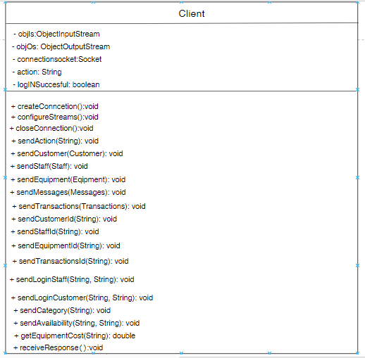

EMPLOYEE UML DIAGRAM

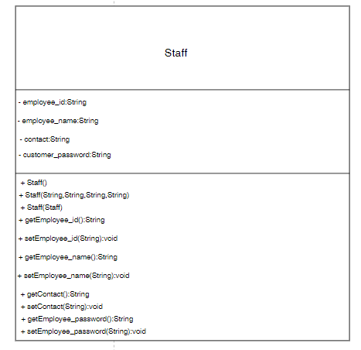

EMPLOYEE DASHBOARD UML DIAGRAM

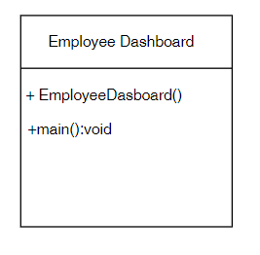

CUSTOMER UML DIAGRAM

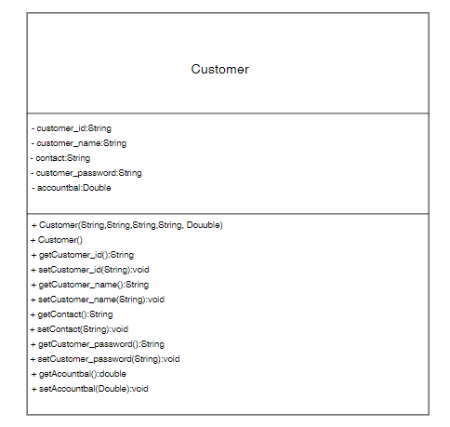

CUSTOMER DASHBOARD UML DIAGRAM

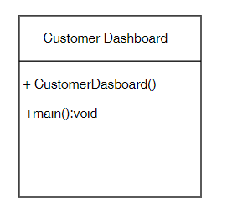

ADDCUSTOMER UML DIAGRAM

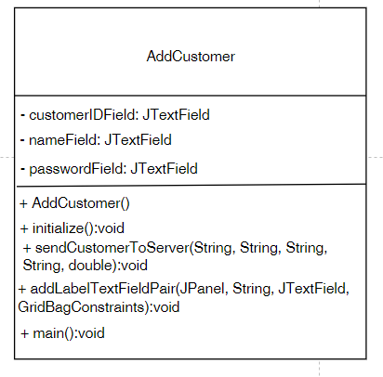

ADDEMPLOYEE UML DIAGRAM

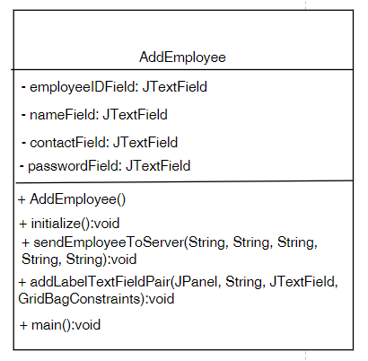

DATE UML DIAGRM

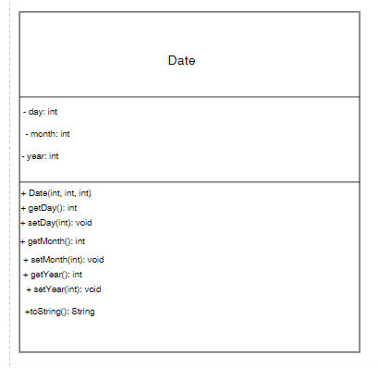

EQUIPMENTINVENTORY UML DIAGRAM

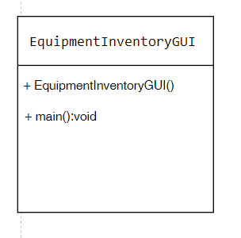

EQUIPMENT UML DIAGRAM

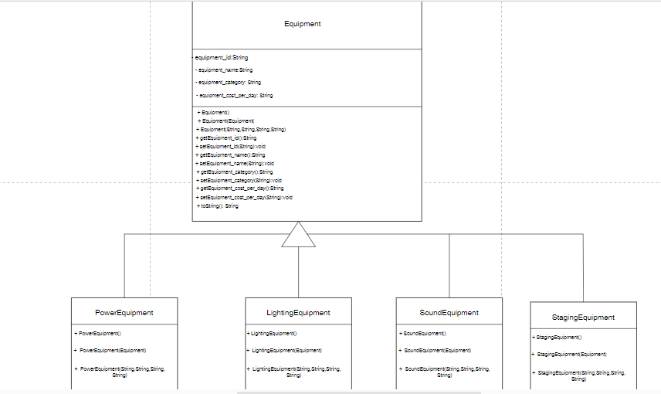

LEAVEMESSAGEGUI UML DIAGRAM

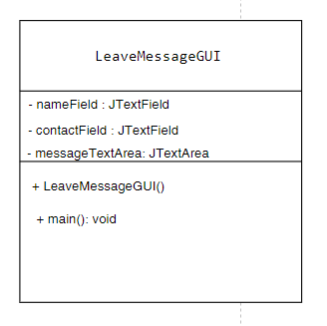

MESSAGES UML DIAGRAM

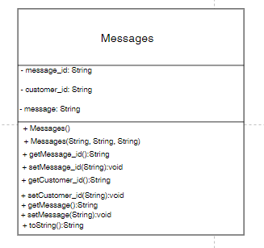

MESSAGINGGUI

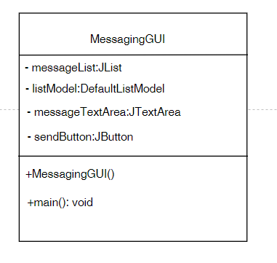

LOGINGUI UML DIAGRAM

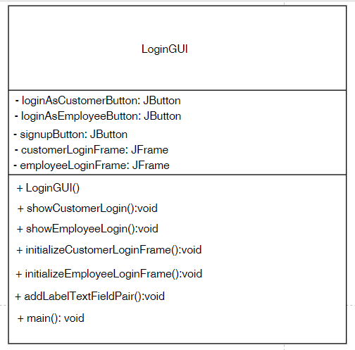

USERSELECTIONGUI

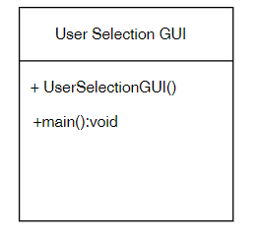

QUOTATIONGENERATOR UML DIAGRAM

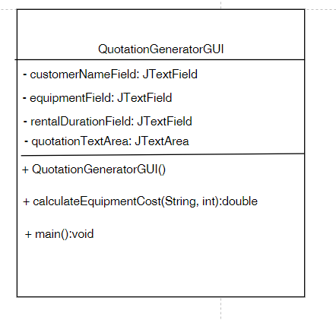

SCHEDULEEQUIPMENTGUI UML DIAGRAM

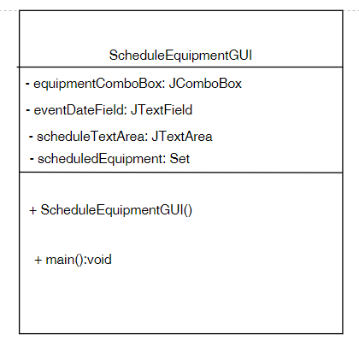

RENTALREQUESTGUI UML DIAGRAM

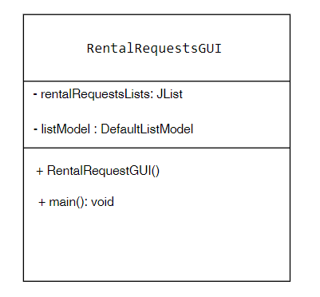

TRANSACTION UML DIAGRAM

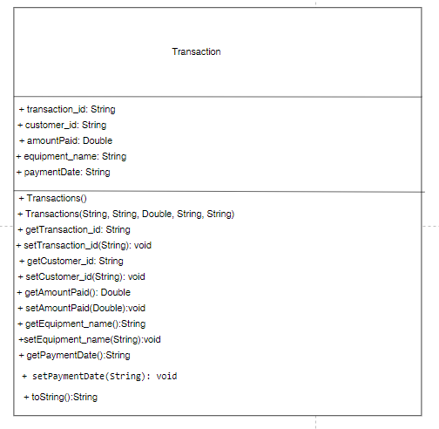

VIEWTRANSACTION UML DIAGRAM

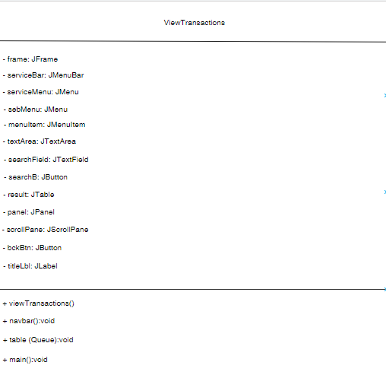

VIEWAVAILABLEEQUIPMENT UML DIAGRAM

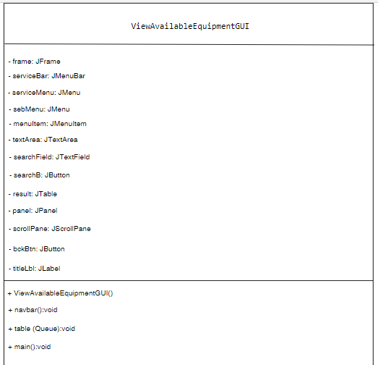

VIEWSNGLETRANSACTIONGUI

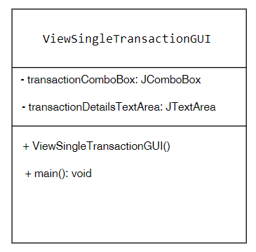

ERD DIAGRAM

